**Administrator Diagnostic Bugs**

1. Manage Diagnostic page:
   1. Clicking on IP CO-LAB in upper left corner opens another tab and duplicates the Manage Diagnostic page instead of returning to Home page.

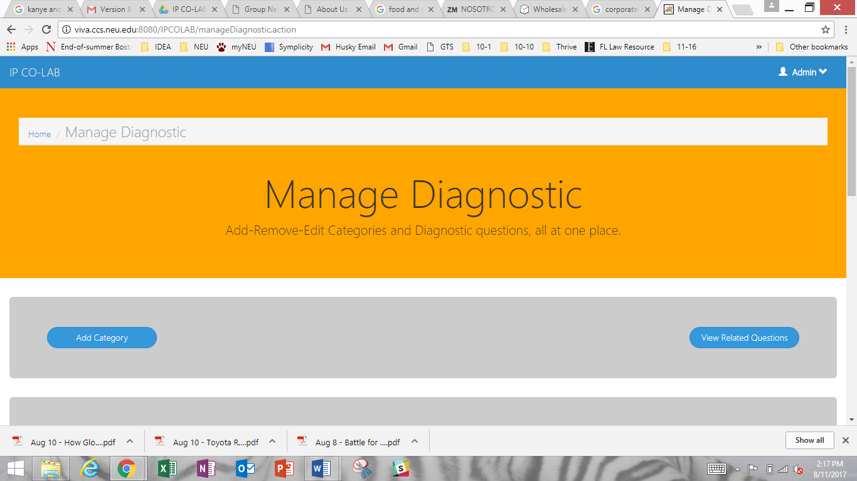

* 1. Refreshing the page after entering a New Category duplicates the Category. Can we eliminate this?

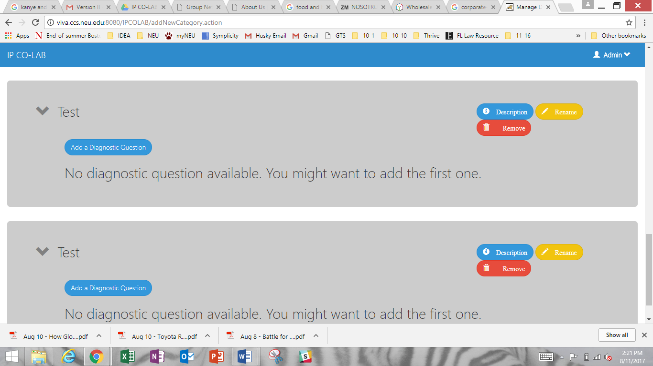

* 1. At times, Diagnostic Questions switch order after a field is edited. There does not seem to be a pattern to the order shift, but the shift does not occur if you edit the same Diagnostic Question multiple times consecutively.

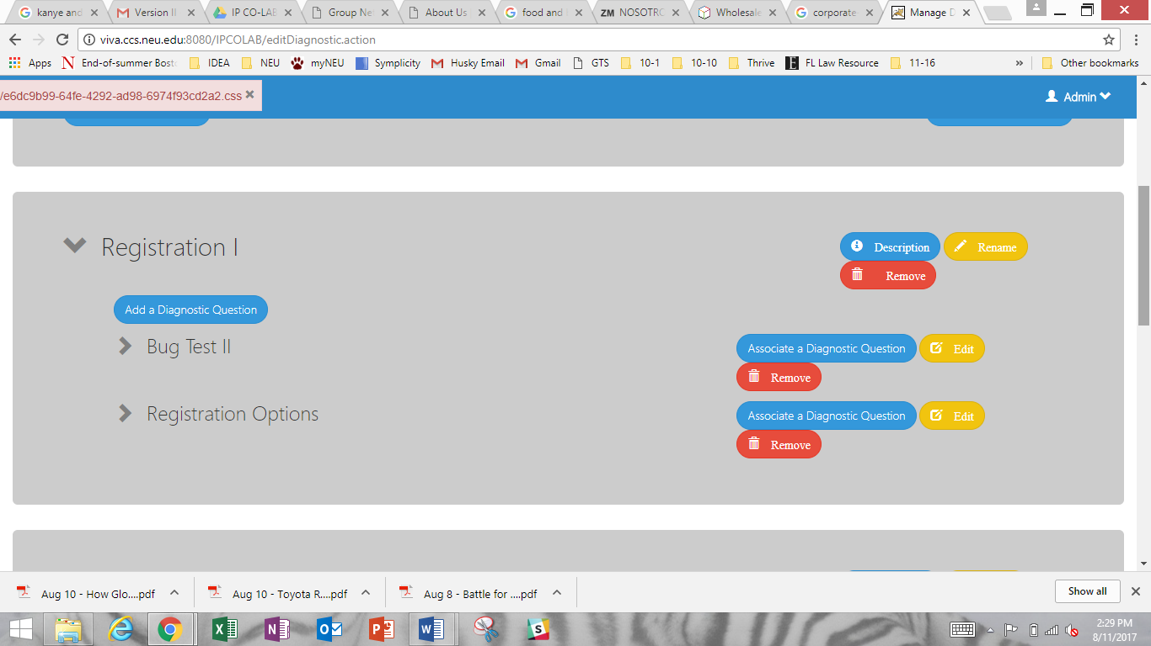

**Administrator User**

1. Manage User Page
   1. Deleting all content from a User Role description leaves a blank field instead of deleting the role. Can we add a delete function?

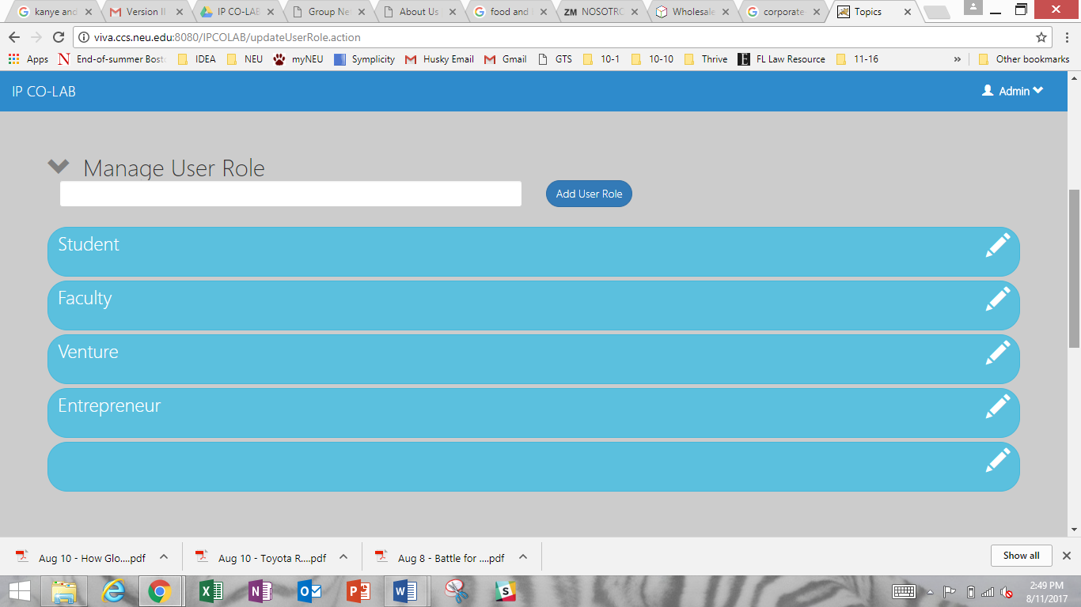

1. User Profile View
   1. Text does not fit within Module description fields.

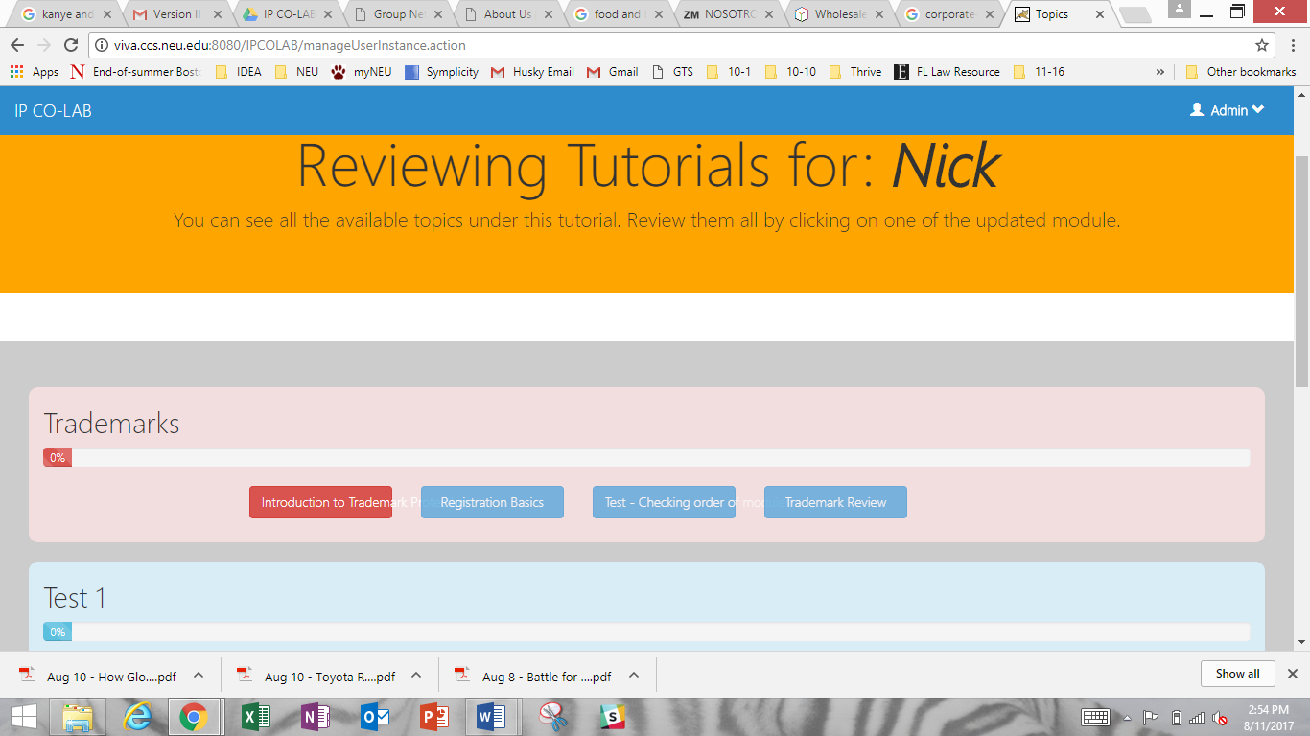

* 1. Text does not fit within Activity question fields.

